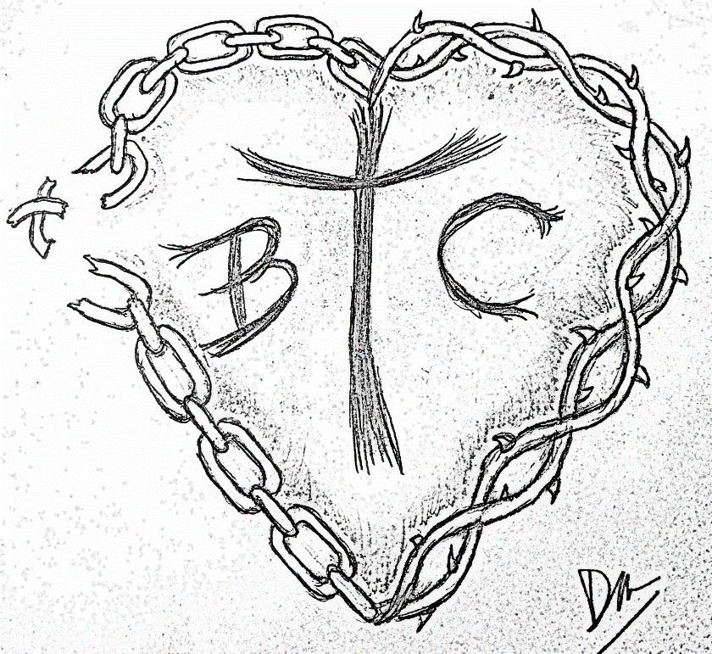
BTC Cornhole Tournament - Registration Form
When: June 8th, 2024
Where: Port Allegany CMA Church
“Back Parking Lot”
414 East Mill Street
Port Allegany, PA 16743

Times: Registration 12:00 PM
Bags fly at 1:00 PM

Cost: $40.00 Per Team

To Register:
Please complete and mail in the form with money to:
Break the Chains Coalition, PO Box 272, Port Allegany PA 16743

Please make checks payable to “Break the Chains Coalition”
Note check “BTC Cornhole Tournament”
Player 1:
Name: _____________________________________ Date of Birth: _____/_____/______
Address: ___________________________________ Gender: ____Male ____ Female
City: ________________State:________Zip:______
Email: ______________________________________

Player 2:
Name: _____________________________________ Date of Birth: _____/_____/______
Address: ___________________________________ Gender: ____Male ____ Female
City: ________________State:________Zip:______
Email: ______________________________________

Waiver: I understand that participating in a cornhole tournament has inherent risks and I hereby assume all risks and hazards or incident to my participation iin this event. I certify that I have decided to participate in the following event (BTC Cornhole Tournament). I further waive, release, absolve, indemnify and agree to hold harmless The Break the Chains Coalition, the borough of Port Allegany, PA, the Port Allegany CMA Church, event sponsors, organizers, volunteers, supervisors, officers, directors, or participants from any claims or injury sustained during my participation in this Cornhole Tournament. I further grant permission to this BTC Cornhole Tournament and any organizers and/or agents conducting this race to use any photographs, video tapes, motion pictures, recordings, or any record of this event for any legitimate purpose.

MY SIGNATURE BELOW INDICATES I HAVE READ AND AGREE TO THE ABOVE WAIVER, OR, AS PARENT OR GUARDIAN, I HAVE READ AND AGREE TO ADBIDE BY THE TERMS ABOVE.
____________________________ ____________________________________ _________________
Signature of Participant Signature of Parent/Guardian (if under 18 yrs) Date

____________________________ ____________________________________ _________________
Signature of Participant Signature of Parent/Guardian (if under 18 yrs) Date

